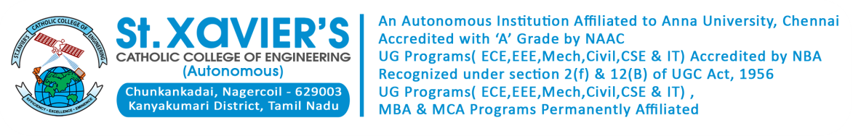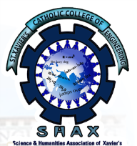

**DEPARTMENT OF HUMANITIES AND SCIENCES**

**SCIENCE AND HUMANTIES ASSOCIATIONOF XAVIER’S (SHAX)**

**ANNUAL REPORT**

**ACADEMIC YEAR 2022-2023**

*Every new beginning comes from some other beginnings end……*

I am pleased to present the 25th Annual Report on the activities and achievements of SHAX, Science and Humanities Association of Xavier’s of the academic year 2022-2023. The Department of Humanities & Sciences encourages the students of all disciplines not only in their academic pursuit but also in furthering their career prospects and giving impetus to their creative potentiality. In addition to that the association inculcate ethical values and promote social responsibility through an innovative learning process in basic sciences and humanities. It also provides students with soft skills and behavioral training programs in order to develop their overall personality and social consciousness. Apart from science subjects the department also strengthens the liberal education of students by developing a deepened understanding of language, the value of critical reading and effective writing.

I am happy to report that during the above period, our Institution is granted with fresh Autonomous status. This academic year starts with a student induction program inorder to help the new students adjust and feel comfortable in the new environment from 10th August to 30th August 2022. With continuation to that a two-week Student Induction Program (SIP) based on Universal Human Values (UHV) was conducted from 7th November to 17th November.

The Inaugural ceremony of the 25th batch, BE/ B.Tech Programmes of St. Xavier’s Catholic College of Engineering was held on 18th November 2022. Rev. Fr. S.Jesu Retnam the Contact Person of the Diocese of Kuzhithurai and the President of the Governing council of St. Xavier’s Catholic College of Engineering presided over the ceremony. Mr.Siva kumar palaniappan, Mindset Mastery Expert, Executive Leadership Coach, highlighted the programme with his very presence.

The Inauguration of SHAX’ was conducted on 15/12/2023 at 10am in the Conference hall. The Faculty Advisor introduced the new office bearers for this academic year. The annual report was presented by the Secretary of SHAX. Dr.J.Mary Gladis , Associate Professor, Dept of Chemistry, IIST, Trivandrum , was the chief guest.

For creating an opportunity to interact with the industry experts we have taken our first year Students to UST Global, Trivandrum on 3rd February and 8th May. Inorder to improve the students critical and creative thinking skills, a session on “Higher order thinking” was conducted for five days from 27/2/2023 to 3/3/2023. by an eminent personality, Dr. S.Lourdunathan, Associate Prof &Head, Department of Philosophy, Arulanandhar College, Madurai.

To build a strong relationship with the parents and to promote the well being of the children a Parent Teachers Interaction meeting was conducted on 11/03/2023 at 2.30 pm in the Conference hall. A Seminar on “Engineering Physics with life applications” was conducted on 19th April at the Conference hall for the first year students. Mr.J.Chittanandha, a senior Physics teacher was the Resource person.

The Department of English organized a one day National Seminar on “English Language Learning for Engineers” on 9th May at the Conference hall. The main objective of the seminar is to make the students to know the importance of English Language. Dr.Pradeep.S.Raj, AP/Kristu Jayanti College, Bangalore and Dr.Tibi Thomas , AP/NMCC, Marthandam acted as the resource persons. The chief guest briefed out the need of English language for Engineers.

The Department of Chemistry is association with the Department of Civil engineering organized an International Conference on Advances in Sustainability of Materials and Environment (ICASME'23)on May 25 and 26. The keynote addresses were given by the eminent specialists in Civil Engineering, Chemistry, Material Science, and Intellectual Property Right. Nearly 86 papers were presented by the authors.

Let me render my heartfelt gratitude to the Coordinator Dr.D.Judson for always being my greatest supporter throughout the year. I also thank all the faculty members and staff members of the Department of Humanities and Sciences , for their valuable cooperation and support.

“The journey is never ending. There's always gonna be growth, improvement, adversity let’s all continue to grow ...........”



Dr.VIDHYA J P

**Faculty Advisor, SHAX**